

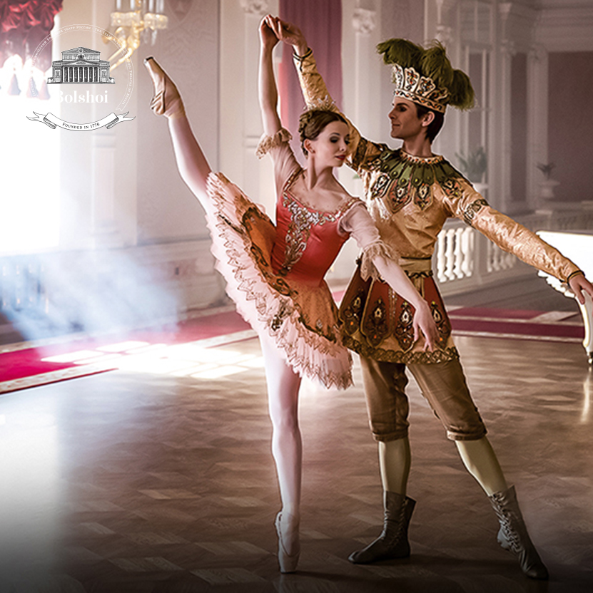

SUNDAY, 10 MAR AT 4 PM

FROM MOSCOW

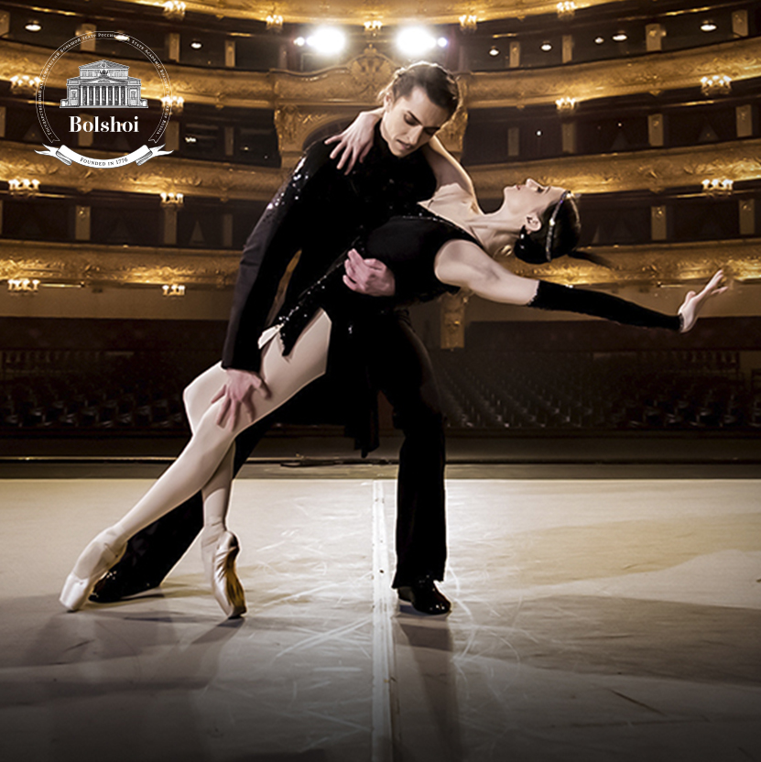

SUNDAY, 7 APR AT 5 PM

FROM MOSCOW

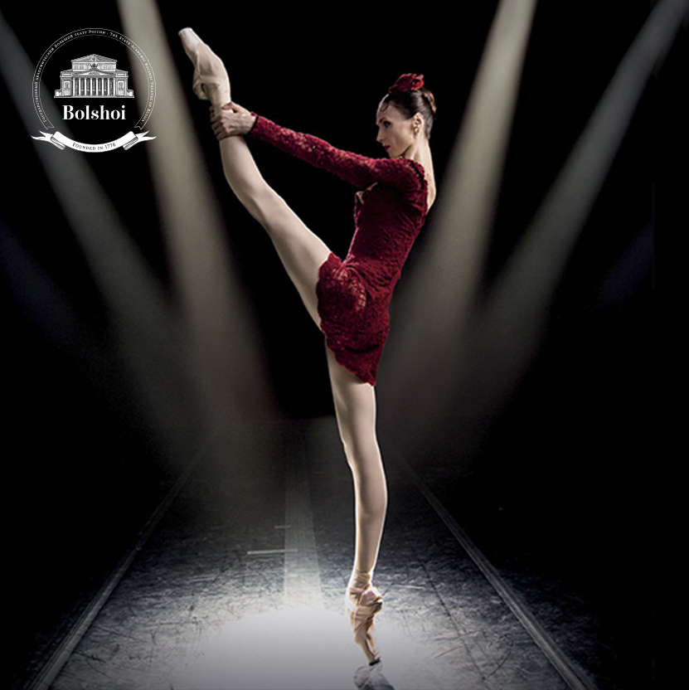

SUNDAY, 19 MAY AT 5 PM

LIVE FROM MOSCOW

SEASON 2018 | 2019

**LA BAYADÈRE**

LIVE FROM MOSCOW

**COMING**   
SOON

­**ACT I**

After a tiger hunt, the warrior Solor is in a hurry to meet the bayadère Nikiya, one of the dancers and guardians of the sacred fire, to whom he has promised his eternal love. Hidden, the High Brahmin watches the scene, jealous of Solor.

The Rajah announces that his daughter Gamzatti will marry Solor. Forced to accept, the young man is impressed by her beauty but does not forget his promise to Nikiya.

Gamzatti overhears that Solor and the priestess are in love and summons Nikiya to the palace for a dramatic confrontation...

**ACT II**

During the engagement feast, Nikiya is barely able to contain her grief while dancing. When she receives a bunch of flowers she believes was sent by Solor, she preciously clutches onto it. But the gift was actually sent by the rajah and Gamzatti and contains a poisonous snake.

**ACT III**

Inconsolable, Solor takes refuge in his dreams. He is visited by ghost-like figures, emerging from the shadows and descending from the mountain. Among them is Nikiya. Solor totally loses touch with reality and follows his beloved into the Kingdom of Shades…

**LA BAYADÈRE  
Ballet in 3 acts**

**SCHEDULE**

15:55 – 16:06 Introduction

16:06 – 16:56 Act I

16:56 – 17:22 Intermission (with interviews)

17:22 – 18:06 Act II

18:06 – 18:32 Intermission (with interviews)

18:32 – 19:13 Act III

19:13 – 19:20 Bows and Credits

MUSIC **LÉON MINKUS**  
CHOREOGRAPHY **YURI GRIGOROVICH**  
MUSICAL DIRECTION **PAVEL SOROKIN**

Presentation and interviews **Katya NOVIKOVA**

**CAST**NIKIYA **OLGA SMIRNOVA**

SOLOR **ARTEMY BELYAKOV**

GAMZATTI **OLGA MARCHENKOVA**

LE RAJAH **ALEXEI LOPAREVICH**

L’IDOLE DORÉE **DAVID MOTTA SOARES**

AND THE BOLSHOI CORPS DE BALLET

DIRECTED BY **ISABELLE JULIEN**

******facebook-flat-vector-logo**

IN PARTNERSHIP WITH

BOOK ON

**BOLSHOIBALLETINCINEMA.COM**

@BolshoiBalletinCinema #LaBayadere

@Pathelive_EN

Pathé Live