

**COMING**

**SOON**

SEASON 2016 | 2017

**A CONTEMPORARY EVENING**

LIVE FROM MOSCOW

instagram-logo_318-53344facebook-flat-vector-logo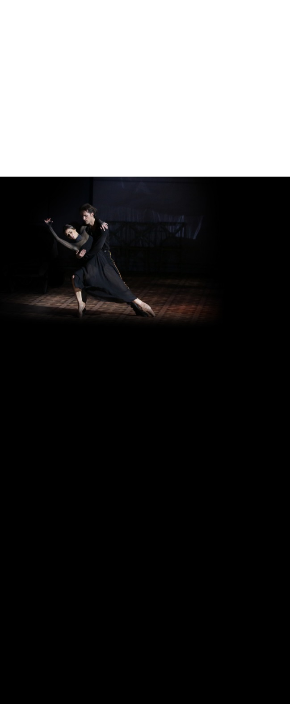

**The Cage**

**Novice**: Ekaterina Krysanova

**The Queen**: Yanina Parienko

**The first intruder**: Nikita Kapustin

**The second intruder**: Alexander Vodopetov

**Russian Seasons**

**Couple in yellow and white**: Yulia Stepanova and Vladislav Lantratov

**Couple in red**: Ekaterina Krysanova and Denis Savin

**Couple in green**: Anna Nikulina and Anton Savichev

**Couple in blue**: Anna Okuneva and Dmitry Dorokhov

**Couple in violet**: Victoria Litvinova and Arthur Mkrtchyan

**Couple in claret red**: Victoria Yakusheva and Mikhail Kochan

**Études**

**Ballerina**: Olga Smirnova

**Principal Dancers**: Semyon Chudin and Artem Ovcharenka

**Share with us on Instagram!**

@BolshoiBalletinCinema

#ContemporaryEvening

Share with us on Instagram and find out more about the 2016-17 season with exclusive pictures and videos!

@Pathelive\_EN / #Bolshoi #ContemporaryEvening

facebook.com/patheliveofficiel

**A HERO**

**OF**

**OUR TIME**

LIVE FROM MOSCOW

NEW PRODUCTION

**SUNDAY 9 APRIL AT 5 PM CEST**

*Pechorin, a young officer, embarks on a journey across the majestic mountains of the Caucasus, on a path set by his passionate encounters. Disillusioned and careless, he inflicts pain upon himself and the women around him…*

“Give me everything, it is still not enough.” The story based on the larger-than-life hero Pechorin is adapted from Mikhail Lermontov’s literary masterpiece in three separate stories recounting his heartbreaking betrayals. Is Pechorin a real hero? Or is he a man like any other? This brand new production by choreographer Yuri Possokhov is a tragic poetic journey that can only be seen at the Bolshoi.

**A CONTEMPORARY EVENING**

**SCHEDULE**

16:00 – 16:06 Presentation

16:06 – 16:21 The Cage

16:21 – 16:47 Intermission

16:47 – 17:29 Russian Seasons

17:29 – 17:55 Intermission

17;55 – 18:41 Études

18:41 – 18:47 Bows and crédits

**THE CAGE**

CHOREOGRAPHY **JEROME ROBBINS**

MUSIC **IGOR STRAVINSKY**

**RUSSIAN SEASONS**

CHOREOGRAPHY **ALEXEI RATMANSKY**

MUSIC **LEONID DESYATNIKOV**

**ÉTUDES**

CHOREOGRAPHY **HARALD LANDER**

MUSIC **CARL CZERNY**

MUSICAL DIRECTION **IGOR DRONOV**

HOSTED BY **KATYA NOVIKOVA**

WORLDWIDE DISTRIBUTION AND PRODUCTION

**PATHÉ LIVE**

DIRECTED BY **VINCENT BATAILLON**

For more information about the season 2016-17:

**www.pathelive.com**