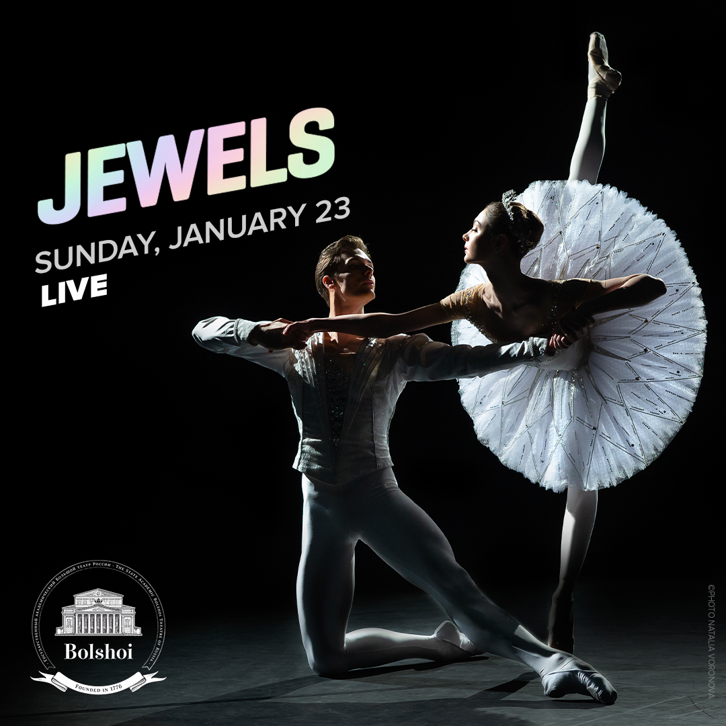

© Natalia Voronova

COMING **SOON**

21|22 SEASON

***THE NUTCRACKER***

**Ballet in 2 acts**

**CAPTURED LIVE IN MOSCOW**

Sunday, December 19, 2021

**SCHEDULE**

11 min Introduction

49 min **Act I**

21 min Intermission with interviews

48 min **Act II**

5 min Bows and credits

MUSIC **PYOTR ILYICH TCHAIKOVSKY**

CHOREOGRAPHY **YURI GRIGOROVICH**

MUSICAL DIRECTION **PAVEL KLINICHEV**

# HOST KATERINA NOVIKOVA

# DIRECTED BY ISABELLE JULIEN

**CAST**

MARIE **MARGARITA SHRAYNER**

THE NUTCRACKER-PRINCE **SEMYON CHUDIN**

DROSSELMEYER **DENIS SAVIN**

THE MOUSE KING **ALEXANDER VODOPETOV**

AND **THE BOLSHOI CORPS DE BALLET**

Captured live in Moscow on Sunday, December 23, 2018.

**ACT I**

On Christmas Eve, Marie’s godfather Drosselmeyer offers her a nutcracker doll. At midnight after the celebrations are over, all the toys come to life. The Nutcracker, at the helm of the tin soldiers, flies to rescue Marie who is threatened by the army of the Mouse King.

**ACT II**

After victoriously defeating the mouse army, the Nutcracker, now a handsome young prince, whisks Marie away into their magic boat to the Land of Sweets. Marie and the Nutcracker-Prince are radiant with happiness: they have reached the kingdom of their dreams. Joyous celebrations can now begin. Yet, it appears it was all just a dream...

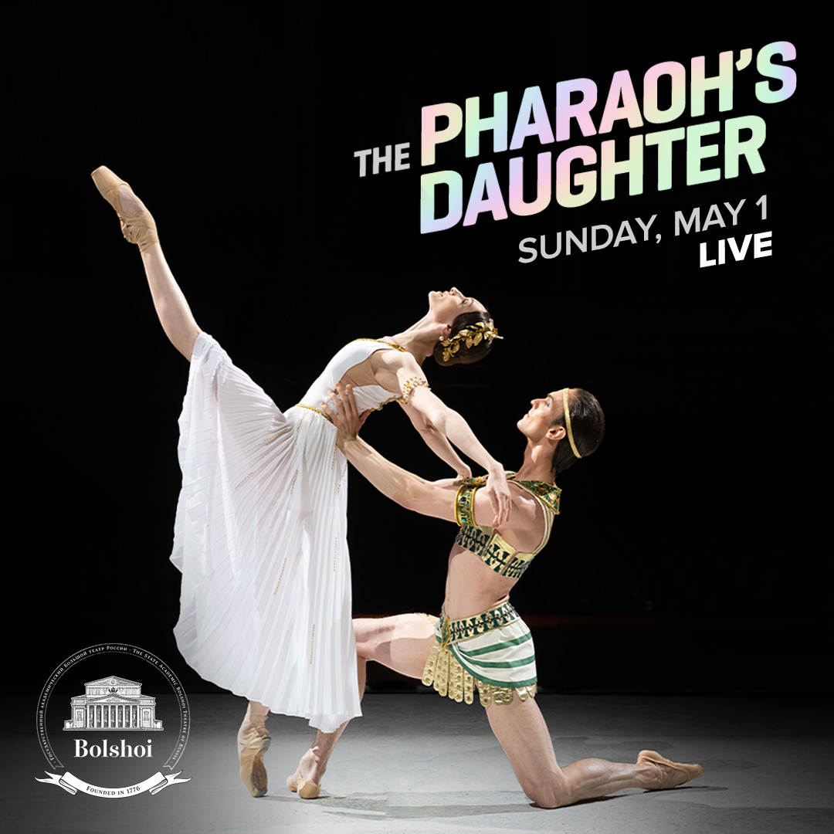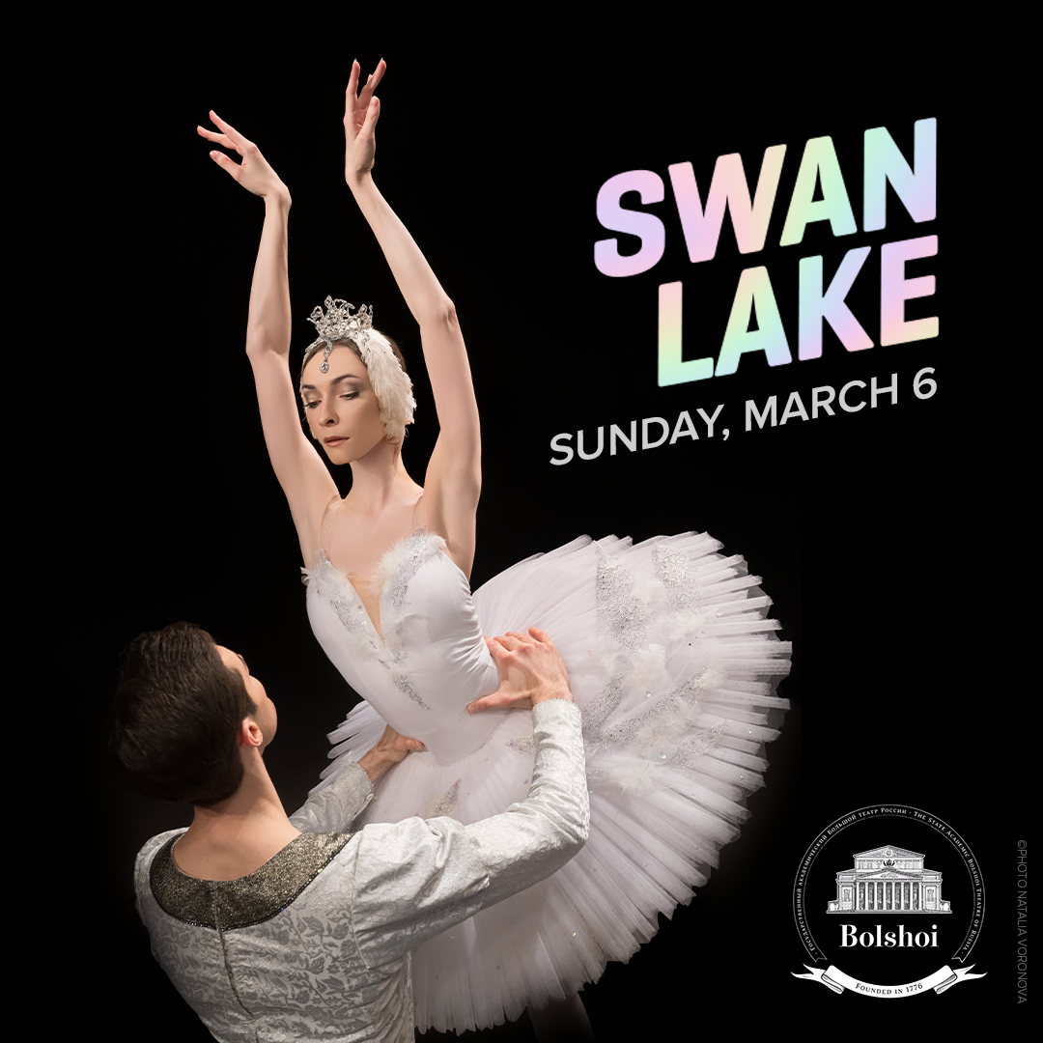facebook-flat-vector-logo

**#NUTCRACKER** Pathé Live @Pathelive_EN @bolshoiballetincinema

IN PARTNERSHIP WITH

TICKETS AT

**BOLSHOIBALLETINCINEMA.COM**