

19|20 SEASON

**LE CORSAIRE**

Ballet in 3 acts

**COMING**

SOON

**CAPTURED LIVE IN MOSCOW**

**SCHEDULE**

10 min Introduction

69 min Act I

15 min Intermission with interviews

48 min Act II

14 min Intermission with interviews

38 min Act III

5 min Bows and credits

MUSIC **ADOLPHE ADAM**

CHOREOGRAPHY **ALEXEI RATMANSKY**

MUSICAL DIRECTION **PAVEL KLINICHEV**

# HOST KATERINA NOVIKOVA

# DIRECTED BY VINCENT BATAILLON

**CAST**

MEDORA **EKATERINA KRYSANOVA**

CONRAD **IGOR TSVIRKO**

SEYD, THE PASHA **ALEXEI LOPAREVICH**

BIRBANTO **DENIS SAVIN**

ZULMEA **NELLI KOBAKHIDZE**

GULNARE **DARIA KHOKHLOVA**

ODALISQUES PAS DE TROIS **ANA TURAZASHVILI,   
ELVINA IBRAIMOVA, XENIA ZHIGANSHINA**

AND **THE BOLSHOI CORPS DE BALLET**

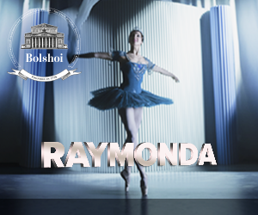

**ACT I**

The market in Adrianople. Slave trader Lankedem presents his goods to Seyd, the Pasha, who decides to buy a beautiful slave. Before leaving, he notices Lankedem’s ward, Medora. Striken by her beauty, he forces Landekem to deliver her to him. However, Medora’s instantly fall in love the pirate Conrad. Under the protection of the pirate’s companions, the two lovers flee. A cave on the pirates’ island: the pirates rise up against their leader who wants to free the slaves. Flowers are brought to them but as soon as Conrad smells them, he falls into a deep sleep. The conspirators succeed in kidnapping Medora.

**ACT II**

The harem of the Pasha. Amongst the women, a slave refuses to bend to the discipline of the harem. Lankedem and Birbanto, one of the rebel pirates, brings a tearful Medora to the Pasha. Conrad and his followers arrive disguised as pilgrims. They try to capture Medora once again but the operation fails and Conrad is made prisoner of the Pasha.

**ACT III**

The harem. The Pasha proposes to free Conrad if Medora agrees to marry him. Medora accepts but plots with Gulnare, who is in love with the Pasha, to swap places during the ceremony. The ploy succeeds. The pirate ship: Medora and Conrad celebrate their reunion but a terrible storm breaks and wrecks the ship…

DATE AND TIME

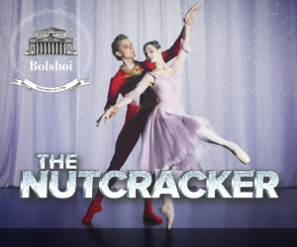

DATE AND TIME

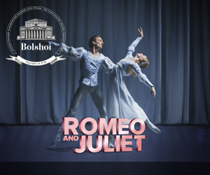

DATE AND TIME



**facebook-flat-vector-logo******

IN PARTNERSHIP WITH

**#LeCorsaire** Pathé Live @Pathelive_EN @bolshoiballetincinema

BOOK ON

**BOLSHOIBALLETINCINEMA.COM**