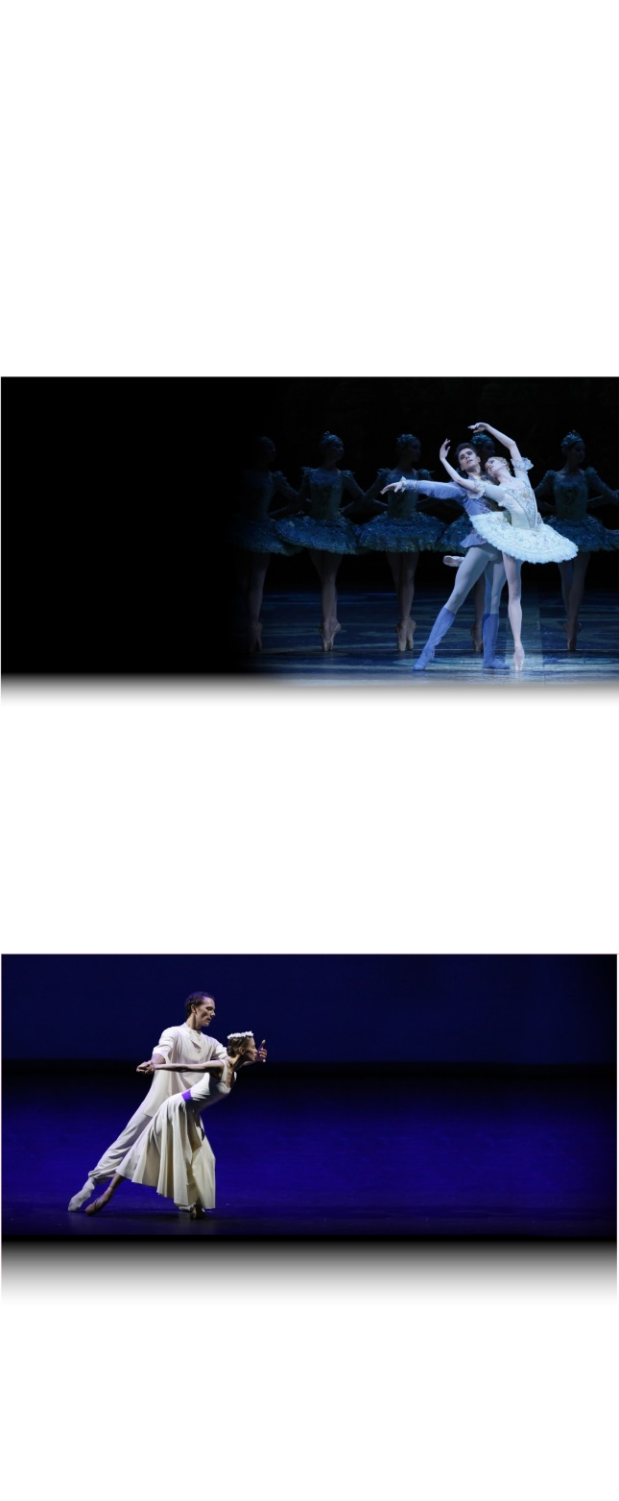

**COMING SOON**

SEASON 2016 | 2017

**SWAN LAKE**

FROM THE MOSCOW STAGE

instagram-logo_318-53344facebook-flat-vector-logo

A CONTEMPORARY

EVENING

FROM THE MOSCOW STAGE

For one evening, the Bolshoi takes on a new challenge with audacity in The Cage by Jerome Robbins, Harald Lander’s Études and Alexei Ratmansky’s Russian Seasons.

THE SLEEPING

BEAUTY

FROM THE MOSCOW STAGE

On her 16th birthday, a curse by the evil Carabosse causes the beautiful Princess Aurora to fall into a deep slumber for 100 years. Only the kiss of a prince could awaken her…

**Act I**

Prince Siegfried is knighted for his birthday. As the celebrations end, he is guided to a lake by a shadow, the Evil Genius.

He meets Odette, white swan by day and woman by night under a curse cast by the Evil Genius. Only true love can conjure this malediction.

**Act II**

Siegfried’s mother introduces princesses coming from all over the world. However, Siegfried cannot take Odette off his mind.

The Evil Genius suddenly arrives with Odile the black swan, Odette’s doppelganger. Siegfried is fooled by her appearance and takes Odile for wife.

In the distance, Odette the white swan appears. As he realises his mistake, Siegfried rushes to the lake…

**Join us on Instagram !**

@BolshoiBalletinCinema

#SwanLake

Join us on Instagram and discover the season 2016-17 with a lot of exclusive content.

facebook.com/patheliveofficiel

@Pathelive\_EN / #Bolshoi #SwanLake

**SWAN LAKE**

Ballet in two acts

Captured live in Moscow on 25 January 2015

**SCHEDULE**

16:00 – 16:06 Introduction by Katya Novikova

16:06 – 17:10 Act I

17:10 – 17:36 Intermission (with interviews)

17:36 – 18:36 Act II

18:36 – 18:45 Bows and crédits

MUSIC **PIOTR ILYTCH TCHAIKOVSKY**

CHOREOGRAPHY **YURI GRIGOROVITCH**

AFTER **MARIUS PETIPA**

MUSICAL DIRECTION **PAVEL SOROKIN**

The Bolshoi Theatre Orchestra

Presentation and interviews **Katya NOVIKOVA**

**DISTRIBUTION**

ODETTE / ODILE **SVETLANA ZAKHAROVA**

PRINCE SIEGFRIED **DENIS RODKIN**

THE EVIL GENIUS **ARTEMY** **BELYAKOV**

THE FOOL **IGOR TSVIRKO**

*and The Bolshoi Corps de Ballet*

WORLDWIDE PRODUCTION & DISTRIBUTION **PATHÉ LIVE**

IN ASSOCIATIONWITH **BEL AIR MEDIA**

DIRECTIED BY **VINCENT BATAILLON**

For more information about the season 2016-17 :

**www.pathelive.com**