

19|20 SEASON

**RAYMONDA**

Sunday, October 27

**COMING**

SOON

**LIVE FROM MOSCOW**

Ballet in 3 acts

**SCHEDULE**

16h00 – 16h10 Introduction

16h10 – 16h58 Act I

16h58 – 17h24 Intermission with interviews

17h24 – 18h04 Act II

18h04 – 18h30 Intermission with interviews

18h30 – 19h03 Act III

19h03 – 19h12 Bows and credits

MUSIC **ALEXANDER GLAZUNOV**

CHOREOGRAPHY **YURI GRIGOROVICH**

MUSICAL DIRECTION **PAVEL KLINICHEV**

# HOST KATERINA NOVIKOVA

# DIRECTED BY ISABELLE JULIEN

**CAST**

RAYMONDA **OLGA SMIRNOVA**

JEAN DE BRIENNE **ARTEMY BELYAKOV**

ABDERAKHMAN **IGOR TSVIRKO**

CLÉMENCE AND HENRIETTE (RAYMONDA'S FRIENDS) **ANASTASIA DENISOVA / MARIA VINOGRADOVA**

AND **THE BOLSHOI CORPS DE BALLET**

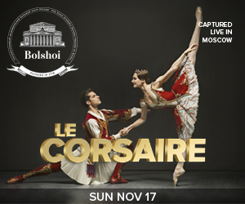

**ACT I**

Jean de Brienne is betrothed to Raymonda, the niece of the Countess Sybil de Daurice. He comes to her castle to bid farewell to her before leaving for а crusade led by the King of Hungary, Andrei II. At night, Raymonda is carried to the enchanted garden of dreams where she meets Jean de Brienne. The happy lovers are together again but suddenly De Brienne disappears. In his place Raymonda sees an Eastern knight who declares his love to her...

**ACT II**

Festivities are underway at the castle.    
Among the guests is the Saracen knight, Abderakhman, accompanied by а magnificent suite. Terrified, Raymonda recognizes him to be the mysterious stranger of her dream. Abderakhman offers Raymonda power and riches in return for her hand and heart but she rejects him. Enraged, Abderakhman tries to abduct her. Fortunately, Jean de Brienne has returned from the crusade. King Andrei II suggests that the two rivals settle their diffеrences in single combat. Jean de Brienne gets the better of Abderakhman and the lovers are united again.

**ACT III**

King Andrei II blesses the marriage of Raymonda аnd Jеаn de Brienne. During the festivities, he is honoured with а big Hungarian dance.

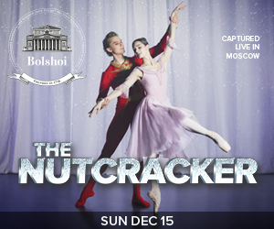

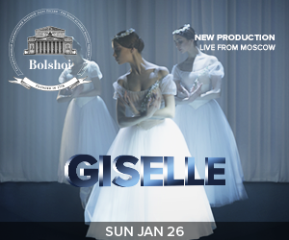



******facebook-flat-vector-logo**

IN PARTNERSHIP WITH

**#Raymonda** Pathé Live @Pathelive_EN @bolshoiballetincinema

BOOK ON

**BOLSHOIBALLETINCINEMA.COM**