

COMING

**SOON**

20|21 SEASON

**THE LADY OF THE CAMELLIAS**

**Ballet in a prologue and 3 acts**

DATE AND TIME

**PROLOGUE / ACT I**

The young bourgeois Armand Duval storms in the apartment of his dead lover and former courtesan Marguerite Gautier. He breaks down, haunted by her memories.

Armand tells the story of how he fell in love with Marguerite, renowned for her captivating beauty but also plagued by illness. Marguerite insists their love must be kept secret so she can remain in her world of luxury and indulgence.

**ACT II**

After an altercation between Armand and a rival suitor, Marguerite publicly admits her love for Armand. His father disapproves of their relationship and without Armand knowing, convinces Marguerite to leave Armand and resume her courtesan life.

**ACT III**

Armand seeks revenge on Marguerite. He starts a relationship with another courtesan and publicly humiliates Marguerite while her heart balances between her love for Armand and the promise made to his father.

**CAPTURED LIVE IN MOSCOW**

Recorded on December 6, 2015

**SCHEDULE**

10 min Introduction

42 min **Prologue / Act I**

11 min Intermission with interview

42 min **Act II**

13 min Intermission with interview

45 min **Act III**

7 min Bows and credits

MUSIC **FRÉDÉRIC CHOPIN**

CHOREOGRAPHY **JOHN NEUMEIER**

MUSICAL DIRECTION **PAVEL SOROKIN**

# HOST KATERINA NOVIKOVA

# DIRECTED BY VINCENT BATAILLON

**CAST**

MARGUERITE GAUTIER **SVETLANA ZAKHAROVA**

ARMAND DUVAL **EDVIN REVAZOV** HAMBURG BALLET GUEST

MANON LESCAUT **ANNA TIKHOMIROVA**

DES GRIEUX **SEMYON CHUDIN**

PRUDENCE DUVERNOY **KRISTINA KRETOVA**

GASTON RIEUX **MIKHAIL LOBUKHIN**

OLYMPIA **DARIA KHOKHLOVA**

SIR DUVAL **ANDREY MERKURIEV**

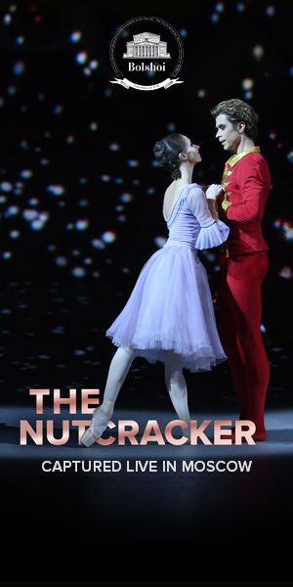

© Natalia Voronova



**#LadyoftheCamellias**  Pathé Live @Pathelive_EN @bolshoiballetincinema

IN PARTNERSHIP WITH

BOOK ON

**BOLSHOIBALLETINCINEMA.COM**

