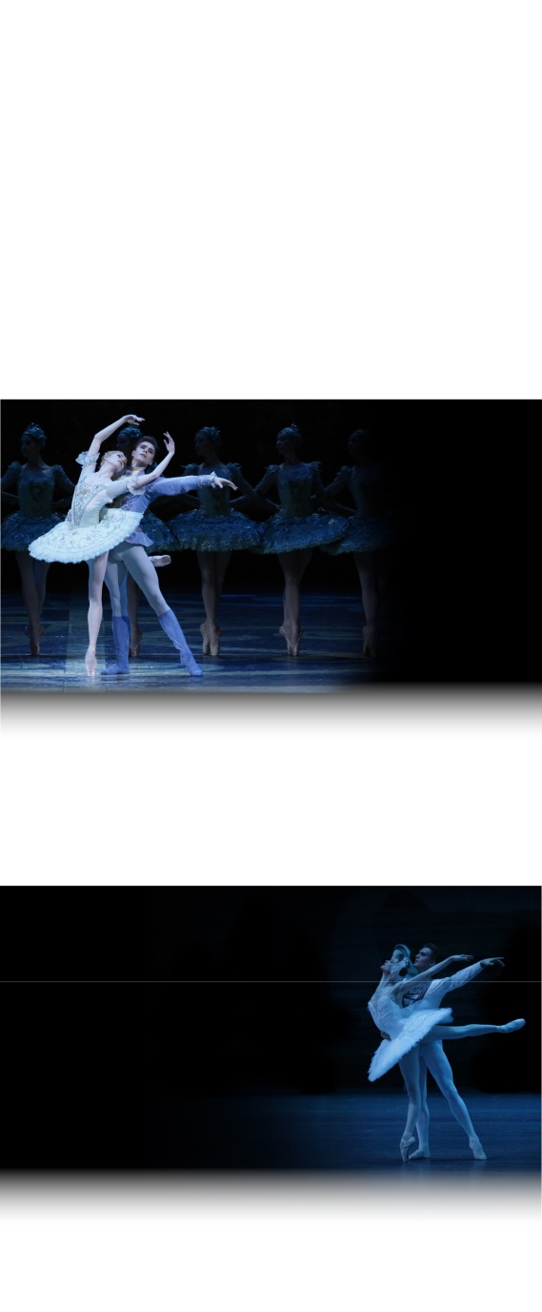

SEASON 2016 | 2017

**THE NUTCRACKER**

CAPTURED LIVE IN MOSCOW

**COMING**

**SOON**

facebook-flat-vector-logoinstagram-logo_318-53344

THE

SLEEPING

BEAUTY

**LIVE**

**FROM MOSCOW**

Sunday, January 22 at 4pm

The Bolshoi’s sumptuous staging with its luxurious sets and costumes gives life to Perrault’s fairy tale unlike any other.

A must-see!

facebook.com/patheliveofficiel

SWAN LAKE

CAPTURED LIVE

IN MOSCOW

Sunday, February 5 at 4pm

A ballet of ultimate beauty and a score of unparalleled perfection born at the Bolshoi in 1877. In the dual role of white swan Odette and her rival black swan Odile, prima ballerina Svetlana Zakharova exudes both vulnerability and cunning through superb technical mastery

**THE NUTCRACKER**

Ballet in two acts

Recorded on December 21st, 2014.

**SCHEDULE**

13min Views of the Bolshoi

4min Presentation

50min Act I

14min Intermission

50min Act II

5min Credits/End

MUSIC **PYOTR TCHAIKOVSKY**

CHOREOGRAPHY **YURI GRIGOROVICH**

AFTER **MARIUS PETIPA**

MUSICAL DIRECTION **PAVEL KLINICHEV**

THE BOLSHOI THEATRE ORCHESTRA

Hosted by **KATYA NOVIKOVA**

**CAST**

MARIE **ANNA NIKULINA**

THE NUTCRACKER **DENIS RODKIN**

DROSSELMEYER **ANDREI MERKURIEV**

THE MOUSE KING **VITALY BIKTIMIROV**

and The Bolshoi Corps de Ballet

WORLDWIDE DISTRIBUTION & PRODUCTION **PATHÉ LIVE**

IN ASSOCIATION WITH **BEL AIR MÉDIA**

DIRECTED BY **VINCENT BATAILLON**

More information on the season 2016-17:

**www.pathelive.com**

**ACT I**

On Christmas Eve, Marie’s godfather Drosselmeyer offers her a nutcracker. At midnight after the celebrations are over, all the toys come to life.

The Nutcracker, at the helm of the tin soldiers, flies to rescue Marie who is threatened by the army of the Mouse King.

**ACT II**

After victoriously defeating the mouse army, the Nutcracker, now a handsome young prince, whisks Marie away into their magic boat to the Land of Sweets.

Marie and the Nutcracker-Prince are radiant with happiness: they have reached the kingdom of their dreams. Joyous celebrations can now begin. Yet, it appears it was all just a dream…

**Share with us on Instagram!**

@BolshoiBalletinCinema

#Nutcracker

Share with us on Instagram and find out more about the 2016-17 season with exclusive pictures and videos!

@Pathelive\_EN / #Bolshoi #Nutcracker