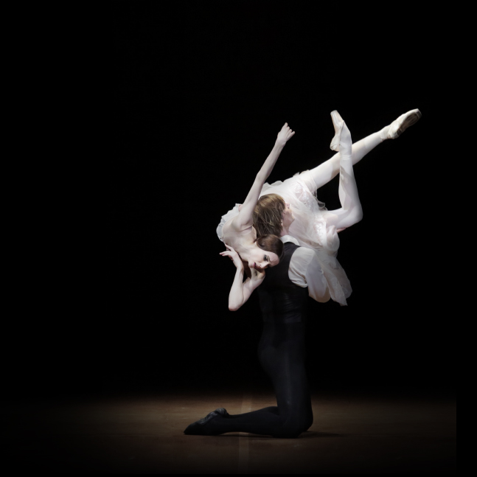

THE LADY OF THE CAMELLIAS

**CHOPIN/NEUMEIER**

**FROM MOSCOW**

**SUNDAY, 4 FEB AT 4 P.M**

SEASON 2017 | 2018

**THE NUTCRACKER**

CAPTURED LIVE FROM MOSCOW

**COMING**   
SOON

**ACT I**

On Christmas Eve, Marie’s godfather Drosselmeyer offers her a nutcracker. At midnight after the celebrations are over, all the toys come to life. The Nutcracker, at the helm of the tin soldiers, flies to rescue Marie who is threatened by the army of the Mouse King.

**ACT II**

After victoriously defeating the mouse army, the Nutcracker, now a handsome young prince, whisks Marie away into their magic boat to the Land of Sweets. Marie and the Nutcracker-Prince are radiant with happiness: they have reached the kingdom of their dreams. Joyous celebrations can now begin. Yet, it appears it was all just a dream...

**Join us on Instagram!**

@BolshoiBalletinCinema

#Nutcracker

Don’t miss exclusive photos and videos from the season 2017-18 of the Bolshoi Ballet in Cinema on our Instagram account!

**THE NUTCRACKER**

Ballet in two acts  
Captured live on 21st December 2014

**SCHEDULE**   
12 min Views of Moscow   
 4 min Introduction   
52 min Act I  
20 min Intermission (with interviews)   
48 min Act II  
 6 min Bows and Credits

MUSIC **PYOTR TCHAIKOVSKY**CHOREOGRAPHY **YURI GRIGOROVICH**After **MARIUS PETIPA**MUSICAL DIRECTION **PAVEL KLINICHEV**Presentation and interviews **KATYA NOVIKOVA**

**CAST**

MARIE **ANNA NIKULINA**   
THE NUTCRACKER – **DENIS RODKIN**  
DROSSELMEYER – **ANDREI MERKURIEV**   
THE MOUSE KING – **VITALY BIKTIMIROV**   
and the Bolshoi Corps de Ballet

DIRECTED BY **VINCENT BATAILLON**

**balletdubolchoiaucinema.com**

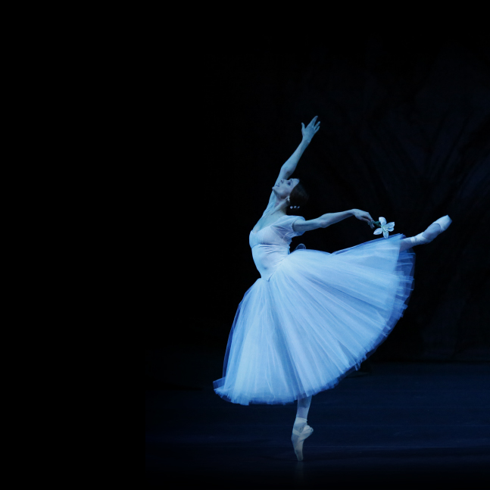facebook-flat-vector-logo

ROMEO

AND

JULIET

**PROKOFIEV/RATMANSKY**

**FROM MOSCOW**

**SUNDAY, 21 JANV AT 4 P.M**

@Pathelive_EN / #Bolshoi #Nutcracker

Pathé Live

GISELLE

**ADAM/GRIGOROVICH**

**FROM MOSCOW**

**SUNDAY, 4 MAR AT 4 P.M**

IN PARTNERSHIP WITH