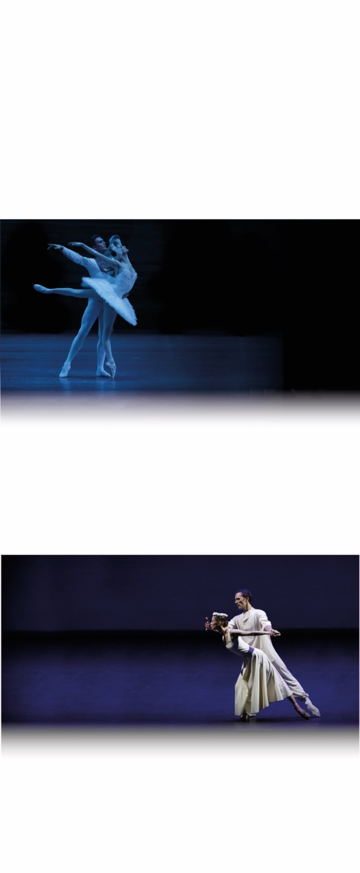

SEASON 2016 | 2017

**SLEEPING BEAUTY**

LIVE FROM MOSCOW

**COMING**

SOON

facebook-flat-vector-logoinstagram-logo_318-53344

**SWAN LAKE**

CAPTURED LIVE

IN MOSCOW

**Sunday, February 5**

**4PM**

A ballet of ultimate beauty and a score of unparalleled perfection born at the Bolshoi in 1877. In the dual role of white swan Odette and her rival black swan Odile, prima ballerina Svetlana Zakharova exudes both vulnerability and cunning through superb technical mastery, alongside the powerful and emotional Siegfried, Denis Rodkin.

@Pathelive\_EN / #Bolshoi #SleepingBeauty

facebook.com/patheliveofficiel

**A CONTEMPORARY EVENING**

LIVE

FROM MOSCOW

**Sunday, March 19**

**4PM**

This encounter between some of the best dancers in the world and masters of contemporary choreography results in an outstanding synthesis of bringing Robbins’s energy, Lander’s virtuosity, and Ratmansky’s witty brilliance to a new level.

**SLEEPING BEAUTY**

Ballet in two acts

**SCHEDULE**

16:00 – 16:05 Presentation

16:05 – 17:10 Act I

17:10 – 17:35 Intermission

17:35 – 18:45 Act II

18:45 – 18:50 Credits/End

MUSIC **PYOTR ILYICH TCHAIKOVSKY**

CHOREOGRAPHY **YURI GRIGOROVICH**

MUSICAL DIRECTION **PAVEL SOROKIN**

The Bolshoi Theatre Orchestra

PRESENTED BY **KATYA NOVIKOVA**

**DISTRIBUTION**

PRINCESS AURORA **OLGA SMIRNOVA**

PRINCE DÉSIRÉ **SEMYON CHUDIN**

THE EVIL FAIRY CARABOSSE **ALEXEI LOPAREVICH**

THE LILAC FAIRY **YULIA STEPANOVA**

CATALABUTTE **VITALY BIKTIMIROV**

BLUEBIRD **ARTEMY BELYAKOV**

PRINCESS FLORINE **ANASTASIA DENISOVA**

And the Bolshoi corps de ballet

WORLDWIDE DISTRIBUTION AND PRODUCTION BY **PATHÉ LIVE**

DIRECTED BY **VINCENT BATAILLON**

For more information about the season 2016-17:

**www.pathelive.com**

**Act I and prologue**

After not being invited to Princess Aurora’s christening, the evil fairy Carabosse casts a curse on the child: she will die at 16 from pricking her finger with a knitting spindle. Fortunately, the Lilac fairy has the power to mitigate the spell. Instead of dying, Aurora will fall into a deep slumber from which only the kiss of a prince could wake her…

**Act II**

100 years have passed. Prince Désiré has yet to find his princess. One evening, the Lilac Fairy summons a vision of Aurora and the Prince sees his beloved maiden in the enchanting Princess. He asks the Lilac Fairy to take him to her and awakens her with a kiss.

**Join us on Instagram!**

@BolshoiBalletinCinema

#SleepingBeauty

Join us on Instagram and discover the season 2016-17 with a lot of exclusive content.