THE BOLSHOI BALLET
LIVE FROM MOSCOW

2017-2018 SEASON

2017-2018 SEASON PRESENTATION

For the 8th consecutive year, the 2017-18 Bolshoi Ballet in Cinema season presents the greatest classics restaged by today’s most celebrated choreographers for a cinema-exclusive experience featuring some of the finest dancers in the world. Three historical ballets recreated by Alexei Ratmansky (Le Corsaire, Romeo and Juliet and The Flames of Paris) will be shown on the big screen alongside John Neumeier’s The Lady of the Camellias and Jean-Christophe Maillot’s riveting The Taming of the Shrew. Three timeless classics and audience-favorites will complete the season: Giselle, The Nutcracker and Coppélia.

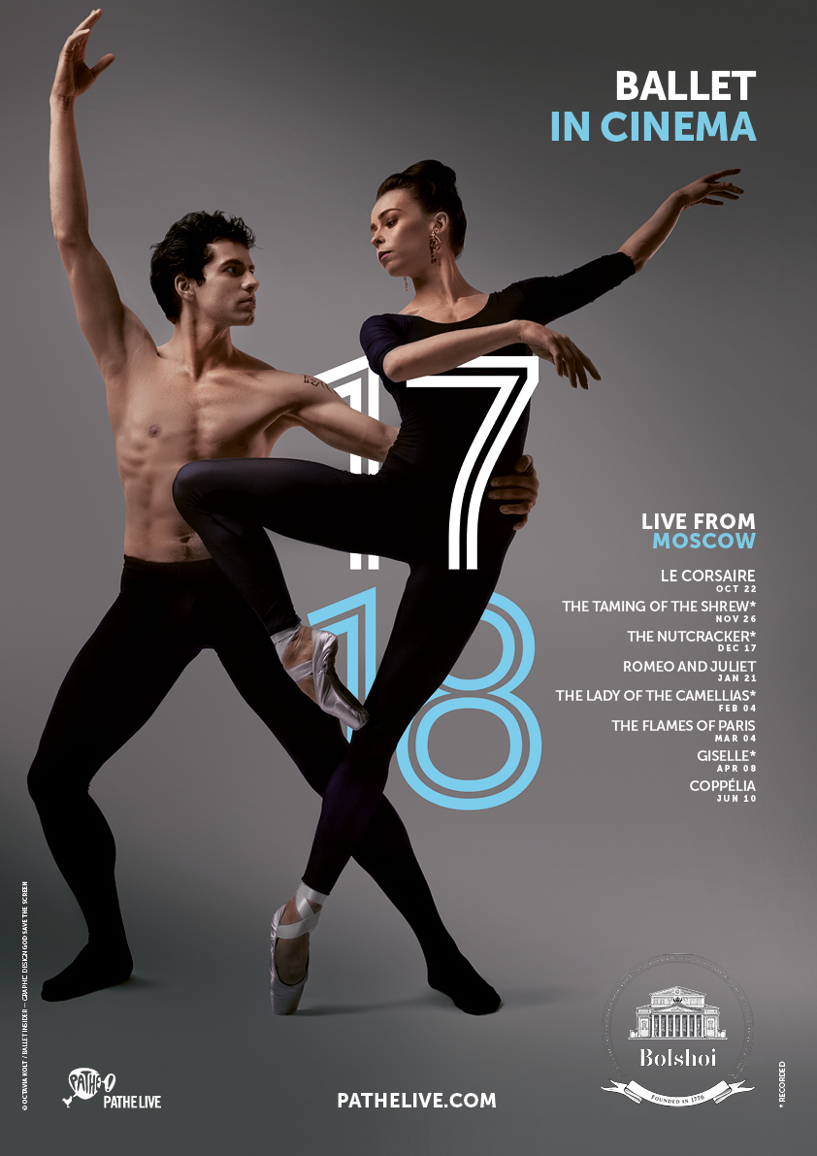

SEASON CALENDAR
Times and durations are for information purposes only and may be subject to modifications.

2017 | OCT | SUN | Oct 22 | LE CORSAIRE | Ratmansky | 5PM CEST
 | NOV | SUN | Nov 26 | THE TAMING OF THE SHREW* | Maillot | 4PM CET
 | DEC | SUN | Dec 17 | THE NUTCRACKER* | Grigorovich | 4PM CET
2018 | JAN | SUN | Jan 21 | ROMEO AND JULIET | Ratmansky | 4PM CET
 | FEB | SUN | Feb 4 | THE LADY OF THE CAMELLIAS* | Neumeier | 4PM CET
 | MAR | SUN | Mar 4 | THE FLAMES OF PARIS | Ratmansky | 4PM CET
 | APR | SUN | Apr 8 | GISELLE* | Grigorovitch | 5PM CEST
 | JUN | SUN | Jun 10 | COPPÉLIA | Vikharev | 5PM CEST
*captured live
SEASON 2017-2018 – THE BALLETS
Times and durations are for information purposes only and may be subject to modifications.

1.

LE CORSAIRE

Date SUN OCT 22, 2017
Time 5PM CEST
Running time 3:35

Music Adolphe Adam
Choreography Alexei Ratmansky
Libretto Jules Henri Vernoy de Saint-Georges and Joseph Mazilier

Cast The Bolshoi Principals, Soloists and Corps de Ballet

Amidst a bustling market, the pirate Conrad falls in love at first sight with the beautiful Medora, the ward of the slave merchant Lankedem’s bazaar. Conrad kidnaps Medora when Lanquedem decides to sell her to the Pasha.

Inspired by Lord Byron’s epic poem and reworked by Alexei Ratmansky from Petipa’s exotic 19th century classic, this miracle of the repertoire is one of the Bolshoi’s most lavish productions. Complete with a magnificent awe-inspring shipwreck and dramatic scenery, this grand romance allows enough dancing for nearly the entire company and made especially for those who seek miracles in theatre.

Official visual

2.

THE TAMING OF THE SHREW

Date SUN 26 NOV, 2017
Time 4PM CET
Running time 2:05

Music Dmitri Shostakovich
Choreography Jean-Christophe Maillot
After William Shakespeare

Cast Ekaterina Krysanova (Katherina), Vladislav Lantratov (Petruchio), Olga Smirnova (Bianca), Semyon Chudin (Lucentio), Anna Tikhomirova (the Housekeeper), Igor Tsvirko (Hortensio), Vyacheslav Lopatin (Gremio), Artemy Belyakov (Baptista)

Baptista struggles to marry off his tempestuous daughter Katharina, a shrew who denies that any man could possibly be her match. However when she meets Petruchio, who is as ill-tempered as she, the two forces of nature ignite an unexpected and explosive encounter.

Acclaimed choreographer Jean-Christophe Maillot brings out the wit, fast-paced athleticism and vibrancy from the Bolshoi Ballet dancers in Shakespeare’s rowdy comedy. Principals Ekaterina Krysanova and Vladislav Lantratov clash, challenge and eventually give themselves to one another in a wonderfully entertaining production that can only be seen at the Bolshoi!

Captured live on Jan 24, 2016

Official visual

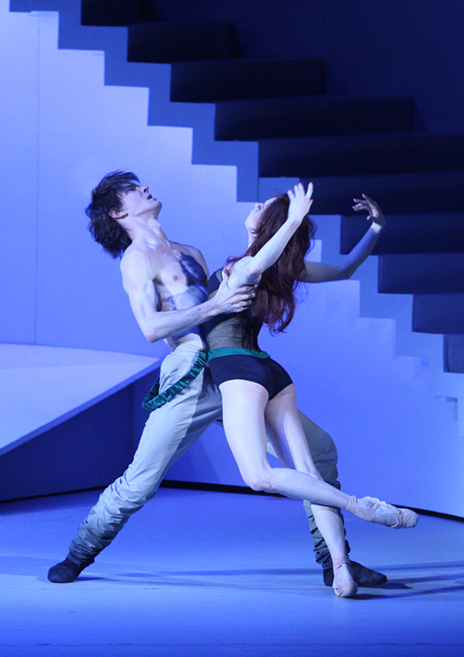

3.

THE NUTCRACKER

Date SUN DEC 17, 2017
Time 4PM CET
Running time 2:15

Music Pyotr Tchaikovsky
Choreography Yuri Grigorovich
Libretto Yuri Grigorovich (after E.T.A. Hoffmann and Marius Petipa).

Cast Denis Rodkin (the Nutcracker Prince), Anna Nikulina (Marie), Andrei Merkuriev (Drosselmeyer), Vitaly Biktimirov (the Mouse King), and the Bolshoi Corps de Ballet.

As the clock strikes midnight on Christmas Eve, Marie’s wooden nutcracker doll comes to life and transforms into a prince! Soon joined by her other toys that have also come to life, Marie and her prince embark on a dreamy unforgettable adventure.

A holiday tradition for the whole family, The Nutcracker sweeps the Bolshoi stage for two hours of enchantment and magic. Along with Tchaikovsky’s cherished score and and some of the Bolshoi’s greatest artists, The Nutcracker remains a treasure not to be missed!

Captured live on Dec 21, 2014

Official visual

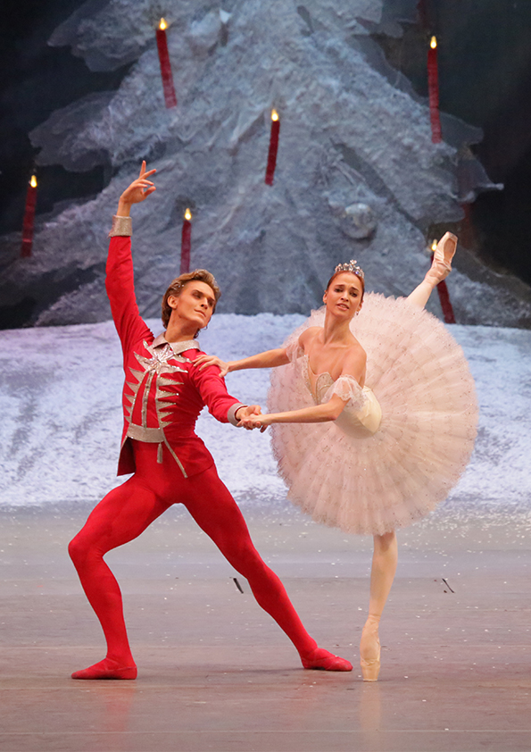

4.

ROMEO AND JULIET
New production

Date SUN JAN 21, 2018
Time 4PM CET
Running time 2:30

Music Sergei Prokofiev
Choreography Alexei Ratmansky
After William Shakespeare

Cast The Bolshoi Principals, Soloists and Corps de Ballet

In Verona, Romeo and Juliet fall madly in love while their respective families, the Montagues and the Capulets, are caught in a bitter rivalry ending in heart-wrenching tragedy…

Alexei Ratmansky, former artistic director of the Bolshoi Ballet, stages the company’s premiere of his production with dramatic urgency and a fresh re-telling of Shakespeare’s beloved classic. His brilliant and detailed adaptation set to Prokofiev’s romantic and cinematic score, reignites the story of literature’s most celebrated star-crossed lovers like no other classical ballet choreographer today.

Official visual

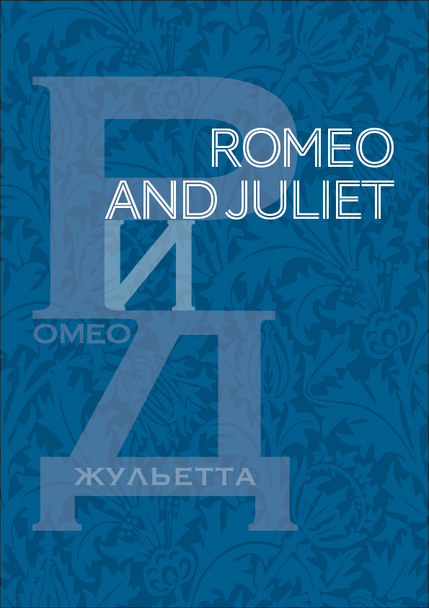
5.

THE LADY OF THE CAMELLIAS

Date SUN FEB 4, 2018
Time 4PM CET
Running time 3:05

Music Frédéric Chopin
Choreography John Neumeier
After Alexandre Dumas fils

Cast Svetlana Zakharova (Marguerite Gautier), Edvin Revazov (Armand Duval), Anna Tikhomirova (Manon Lescaut), Semyon Chudin (Des Grieux), Kristina Kretova (Prudence Duvernoy), Mikhail Lobukhin (Gaston Rieux), Anna Antropova (Nanina), Andrei Merkuriev (Monsieur Duval), Daria Khokhlova (Olympia)

As he arrives in Paris for the first time, the young and naive Armand is utterly captivated after meeting the ravishing and most desirable courtesan Marguerite Gautier. Their encounter gives birth to a passionate yet doomed love…

Alexandre Dumas fils’s novel comes to life on the Bolshoi stage, with prima Svetlana Zakharova as the ailing Marguerite seeking love and redemption from her life as a courtesan. The Bolshoi brings choreographer John Neumeier’s work of rare beauty and tragic depth to new emotional heights, accompanied by Chopin’s romantic piano score.

Captured live on Dec 06, 2015

Official visual

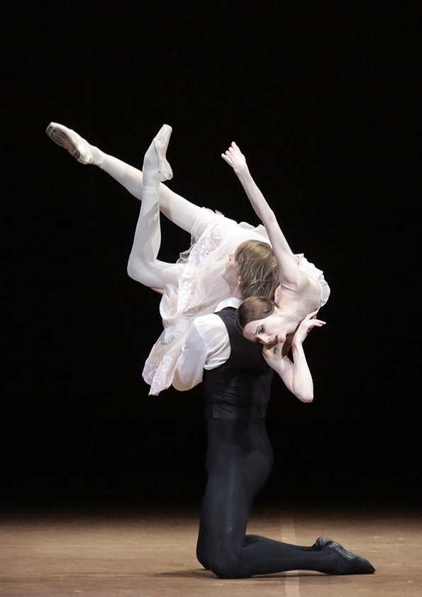

6.

THE FLAMES OF PARIS

Date SUN MAR 4, 2018
Time 4PM CET
Running time 2:15

Music Boris Asafiev
Choreography Alexei Ratmansky
Libretto Nikolai Volkov and Vladimir Dmitriev

Cast The Bolshoi Principals, Soloists and Corps de Ballet

In the era of the French Revolution, Jeanne and her brother Jérôme leave Marseille for Paris in support of the revolutionary effort that is taking over the capital. While fighting for freedom, they both encounter love along the way…

Very few ballets can properly depict the Bolshoi’s overflowing energy and fiery passion as can Alexei Ratmansky’s captivating revival of Vasily Vainonen’s The Flames of Paris. With powerful virtuosity and some of the most stunning pas de deux, the Bolshoi Ballet displays an exuberance almost too enormous for the Moscow stage.

Official visual

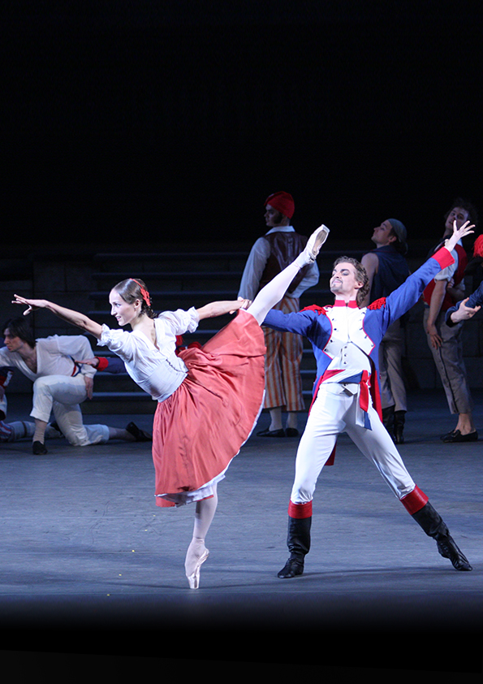
7.

GISELLE

Date SUN APR 8, 2018
Time 5PM CEST
Running time 2:20

Music Adolphe Adam
Choreography Yuri Grigorovich
Libretto Theophile Gautier and Jean-Henry Saint-Georges

Cast Svetlana Zakharova (Giselle), Sergei Polunin (Albrecht), Ekaterina Shipulina (Myrtha), Denis Savin (Hans), and the Bolshoi Corps de Ballet.

When Giselle learns that her beloved Albrecht is promised to another woman, she dies of a broken heart in his arms. While Albrecht grieves, she returns from the dead as a Wili, a vengeful spirit meant to make unfaithful men dance until death…

Prima ballerina Svetlana Zakharova personifies this ultimate ballerina role in the classical repertoire, alongside the sensational Sergei Polunin as Albrecht, in this chilling, yet luminous ballet that continues to captivate audiences for over 150 years at the Bolshoi.

Captured live on Oct 11, 2015

Official visual

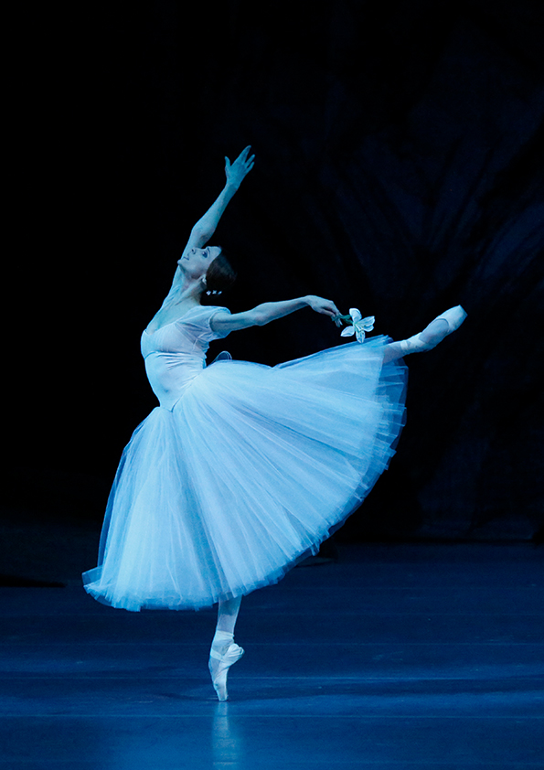
8.

COPPÉLIA

Date SUN JUN 10, 2018
Time 5PM CEST
Running time 2:45

Music Leo Delibes
Choreography Sergei Vikharev
Libretto Charles Nuitter and Arthur Saint-Leon

Cast The Bolshoi Principals, Soloists and Corps de Ballet

Swanhilda notices her fiancee Franz is infatuated with the beautiful Coppélia who sits reading on her balcony each day. Nearly breaking up the two sweethearts, Coppelia is not what she seems and Swanhilda decides to teach Franz a lesson…

The Bolshoi’s unique version of Coppélia exhibits a fascinating reconstruction of the original 19th century choreography of this ebullient comedy involving a feisty heroine, a boyish fiancee with a wandering eye, and an old dollmaker. The company’s stunning corps de ballet shines in the divertissements and famous “dance of the hours,” and its principals abound in youthful energy and irresistible humor in this effervescent production.

Official visual

