

SEASON 2016 | 2017

**THE BRIGHT STREAM**

CAPTURED LIVE IN MOSCOW

**COMING**

**SOON**

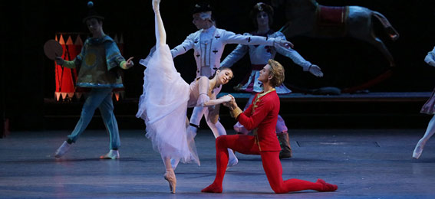facebook-flat-vector-logoinstagram-logo_318-53344

**THE NUTCRACKER**

Sunday, Dec. 18

Am Weihnachtsabend verwandelt sich

On Christmas Eve, Marie’s wooden nutcracker doll transforms into a beautiful prince who takes her on a magical journey. Before they leave, they must confront the Mouse King whose army is threatening Marie…

**THE SLEEPING BEAUTY**

Sunday, Jan. 22 – LIVE

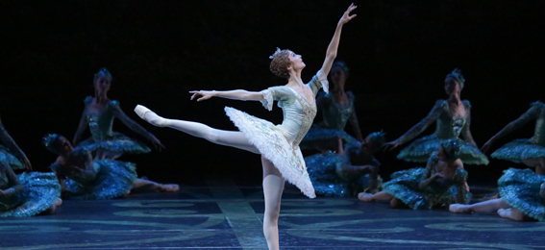

On her 16th birthday, a curse by the evil Carabosse causes the beautiful Princess Aurora to fall into a deep slumber for 100 years. Only the kiss of a prince could awaken her…

**ACT I**

An artist’s troupe from Moscow arrives at the Bright Stream, a collective farm in the country. Zina, who lives at the Bright Stream, recognises one of the ballet dancers to be an old friend from ballet school. Zina introduces the ballerina to her husband Piotr.

Piotr seems to be falling for the ballerina’s beauty, to Zina’s dismay…

**ACT II**

Zina’s shared her feeling with the ballerina who suggests that the both of them and the ballerina’s husband exchange roles for the evening in order to teach the unfaithful Piotr a lesson…

**Share with us on Instagram!**

@BolshoiBalletinCinema

#BrightStream

Share with us on Instagram and find out more about the 2016-17 season with exclusive pictures and videos!

facebook.com/patheliveofficiel

@Pathelive\_EN / #Bolshoi #BrightStream

**THE BRIGHT STREAM**

Ballet in two acts

Captured live on April 29, 2012

**SCHEDULE**

13min Views of the Bolshoi

6min Presentation

41min Act I

17min Intermission

49min Act II

6min Credits/End

MUSIC **DMITRI SHOSTAKOVICH**

CHOREOGRAPHY **ALEXEI RATMANSKY**

MUSICAL DIRECTION **PAVEL SOROKIN**

The Bolshoi Theatre Orchestra

Hosted by **KATYA NOVIKOVA**

**CAST**

ZINA **SVETLANA LUNKINA**

PIOTR **MIKHAIL LOBUKHIN**

THE BALLERINA **MARIA ALEXANDROVA**

THE BALLET DANCER **RUSLAN SKVORTSOV**

THE ACCORDIONIST **DENIS SAVIN**

THE OLD DACHA DWELLER **ALEXEI LAPOREVICH**

And the Bolshoi corps de ballet

WORLDWIDE DISTRIBUTION & PRODUCTION **PATHÉ LIVE**

IN ASSOCIATION WITH **BEL AIR MÉDIA**

DIRECTED BY **VINCENT BATAILLON**

More information on the season 2016-17:

**www.pathelive.com**