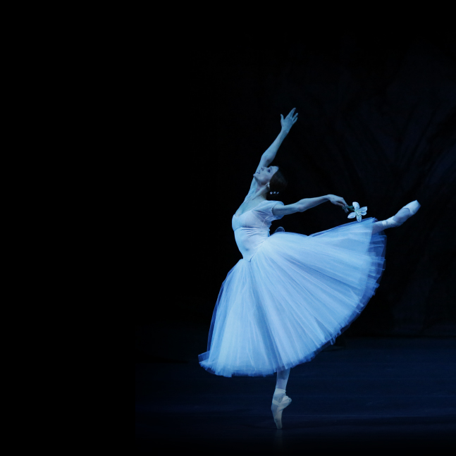

GISELLE

**ADAM/GRIGOROVICH**

**FROM MOSCOW**

**SUNDAY, 8 APRIL AT 5 P.M**

SEASON 2017 | 2018

**THE FLAMES OF PARIS**

LIVE FROM MOSCOW

**COMING**   
SOON

**ACT I**

Marseille. A battalion is making its way to Paris. Jérôme and his sister Jeanne encounter the Marquis Costa de Beauregard with his daughter, Adeline, along the way. The Marquis makes advances to Jeanne and Jérôme comes to his sister’s defense, but he is arrested. Adeline frees Jérôme. Furious, the Marquis sends Adeline away to Paris with her keeper.

The Marquis and Adeline arrive in Paris where a court ballet begins. King Louis XVI and Marie-Antoinette make their entrance. Oaths of loyalty and toasts to the prosperity of the monarchy follow.

**ACT II**

A square in Paris. The battalion from Marseille signals the start of the assault on the Tuileries. Suddenly, Jérôme catches sight of Adeline and rushes over to her, they declare their love for each other. Her sinister keeper spies on their meeting. After a volley of cannon firing, the crowd dashes off to storm the Tuileries and takes the palace, led by Jeanne.

Members of the new government mount the tribune. The President of the Convention unites the hands of Jeanne and Philippe, the first young newlyweds of the new Republic. In the distance the muffled thuds of the falling knife of the guillotine is heard. In order to get revenge, her keeper reveals Adeline’s true origins. The crowd demands her death…

**THE FLAMES OF PARIS**Ballet in two acts

**SCHEDULE**

15:55 – 16:00 Views of Moscow

16:00 – 16:04 Introduction

16:04 – 17:04 Act I

17:04 – 17:25 Intermission (with interviews)

17:25 – 18:13 Act II

18:13 – 18:18 Bows and Credits

MUSIC **BORIS ASAFIEV**CHOREOGRAPHY **ALEXEI RATMANSKY**MUSICAL DIRECTION **PAVEL SOROKIN**

Presentation and interviews **KATYA NOVIKOVA**

**CAST**

JEANNE – **MARGARITA SHRAINER**JÉRÔME – **DENIS SAVIN**

PHILIPPE – **IGOR TSVIRKO**

THE MARQUIS COSTA DE BEAUREGARD –

**SEMYON CHUDIN**

ADELINE – **ANA TURAZASHVILI**

JARCASSE, THE KEEPER – **IRINA ZIBROVA**and the Bolshoi Corps de Ballet

DIRECTED BY **VINCENT BATAILLON**

**bolshoiballetincinema.com**

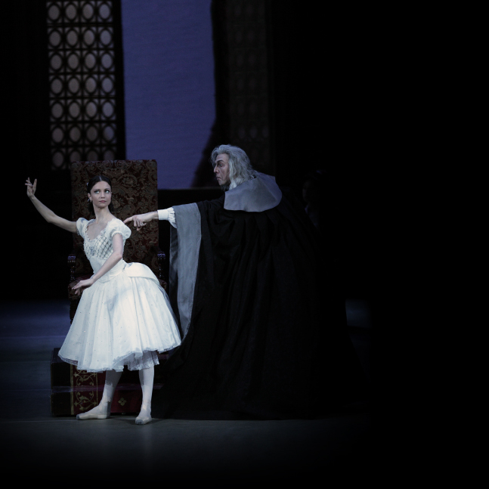facebook-flat-vector-logo

COPPÉLIA

**DELIBES/VIKHAREV**

**LIVE FROM MOSCOW**

**SUNDAY, 10 JUNE 5 P.M**

@BolshoiBalletinCinema

@Pathelive_EN / #Bolshoi #TheFlamesofParis

Pathé Live

IN PARTNERSHIP WITH