

**NEW SEASON**

**2017-2018**



**LE CORSAIRE**

**THE TAMING OF THE SHREW**

**THE NUTCRACKER**

**ROMEO AND JULIET**

**THE LADY OF THE CAMELLIAS**

**THE FLAMES OF PARIS**

**GISELLE**

**COPPÉLIA**

SEE AT THE BACK

FOR MORE INFORMATION

#Bolshoi1718

SEASON 2016 | 2017

**A HERO OF OUR TIME**

LIVE FROM MOSCOW

**A HERO OF OUR TIME**

Ballet In 3 Acts

**SCHEDULE**

17:00 – 17:06 Presentation

17:06 – 18:09 Acts I and II

18:09 – 18:35 Intermission

18:35 – 19:40 Act III

19:40 – 19:50 Bows and credits

MUSIC **ILYA DEMUTSKY**

CHOREOGRAPHY **YURI POSSOKHOV**

LIBRETTO **KIRILL SEREBRENNIKOV**

AFTER [**MIKHAIL LERMONTOV**](https://www.google.fr/search?biw=1680&bih=933&q=Lermontov&stick=H4sIAAAAAAAAAOPgE-LUz9U3MDHILUpWAjMNLZMtk7VkspOt9JPy87P1y4syS0pS8-LL84uyrRJLSzLyiwCKsYOCNgAAAA&sa=X&sqi=2&ved=0ahUKEwjNnNXJ2dPSAhVMPBQKHfNlBgUQmxMIlQEoATAP)

The Bolshoi Theatre Orchestra

HOSTED BY **KATYA NOVIKOVA**

**CAST**

PECHORIN **IGOR TSVIRKO/ARTEM OVCHARENKO/ RUSLAN SKVORTSOV**

BELA **OLGA SMIRNOVA**

UNDINE **EKATERINA SHIPULINA**

PRINCESS MARY **SVETLANA ZAKHAROVA**

VERA **KRISTINA KRETOVA**

WORLDWIDE DISTRIBUTION AND PRODUCTION BY **PATHÉ LIVE**

DIRECTED BY **VINCENT BATAILLON**

For more information about the ballet in cinema:

www.pathelive.com

instagram-logo_318-53344

**BELA**

Pechorin, an officer exiled in the Caucasus, notices the beautiful young Bela and kidnaps her to make her his own. After having seduced her, he suddenly loses interest in the young Circassian girl, leaving her vulnerable to great danger...

**TAMAN**

In a small coastal town by the Black Sea called Taman, Pechorin stays in a shabby house. He quickly realizes that its dwellers, an old lady, a young woman named Undine and a blind man, are all smugglers. Fearing that Pechorin will alert them to the authorities, Undine then tries to drown him...

**MARY**

Spending the last part of his exile in a spa town for recovering army officers, Pechorin sees his friend Grushnitsky, who is in love with Mary, a princess.  Pechorin decides to entertain his boredom by toying with Mary, who falls in love with him.  Knowing he has no romantic feelings for her, he humiliates and abandons her, is challenged into a duel by Grushnitsky, and ultimately loses Vera, his real love...

**Join us on Instagram!**

@BolshoiBalletinCinema

#AHeroOfOurTime

Don’t miss exclusive photos and videos from the Bolshoi Ballet in Cinema on Instagram!



facebook-flat-vector-logo

@Pathelive\_EN / #Bolshoi #AHeroOfOurTime

facebook.com/patheliveofficiel

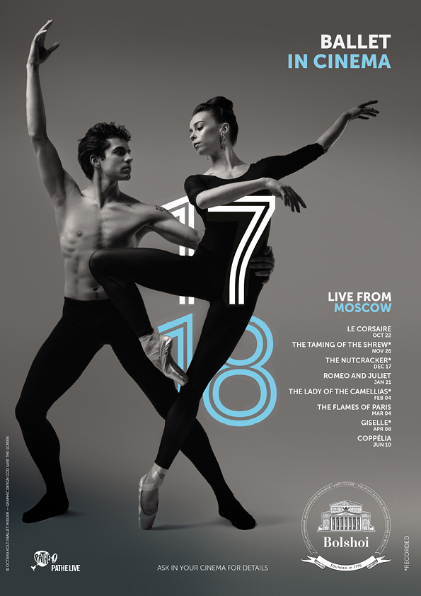

ASK YOUR CINEMA AND FOLLOW US ON INSTRAGRAM

**@BOLSHOIBALLETINTINCINEMA**

FOR MORE INFORMATION ABOUT THE NEW SEASON

**NEW SEASON 2017-2018**

**THE BOLSHOI BALLET IN CINEMA**

For the 8th consecutive year, the 2017-18 Bolshoi Ballet in Cinema season presents the greatest classics restaged by today’s most celebrated choreographers for a cinema-exclusive experience featuring some of the finest dancers in the world. Three historical ballets recreated by Alexei Ratmansky (*Le Corsaire*, *Romeo and Juliet* and *The Flames of Paris*) will be shown on the big screen alongside John Neumeier’s *The Lady of the Camellias* and Jean-Christophe Maillot’s riveting *The Taming of the Shrew*. Three timeless classics and audience-favorites will complete the season: *Giselle*, *The Nutcracker* and *Coppélia*.

**LE CORSAIRE Adam – Ratmansky**

SUN OCT 22|5PM CEST

**THE TAMING OF THE SHREW Shostakovich – Maillot**

SUN NOV 26|4PM CET

**THE NUTCRACKER Tchaikovsky – Grigorovich**

SUN DEC 17|4PM CET

**ROMEO AND JULIET Prokofiev – Ratmansky**

SUN JAN 21|4PM CET

**NEW PRODUCTION**

**THE LADY OF THE CAMELLIAS Chopin – Neumeier**

SUN FEB 4|4PM CET

**THE FLAMES OF PARIS Asafiev – Ratmansky**

SUN MAR 4|4PM CET

**GISELLE Adam – Grigorovich**

SUN APR 8 |5PM CEST

**COPPÉLIA Delibes – Vikharev**

SUN JUN 10|5PM CEST